# 1, Materials

Example link:

<https://www.learnopencv.com/deep-learning-based-object-detection-using-yolov3-with-opencv-python-c/>

Source code:

<https://github.com/spmallick/learnopencv>

# 2, Modifications for running on Elise Board

ObjectDetection-YOLO/object_detection_yolo.cpp



# 3, Test results

## 3.1 Input image

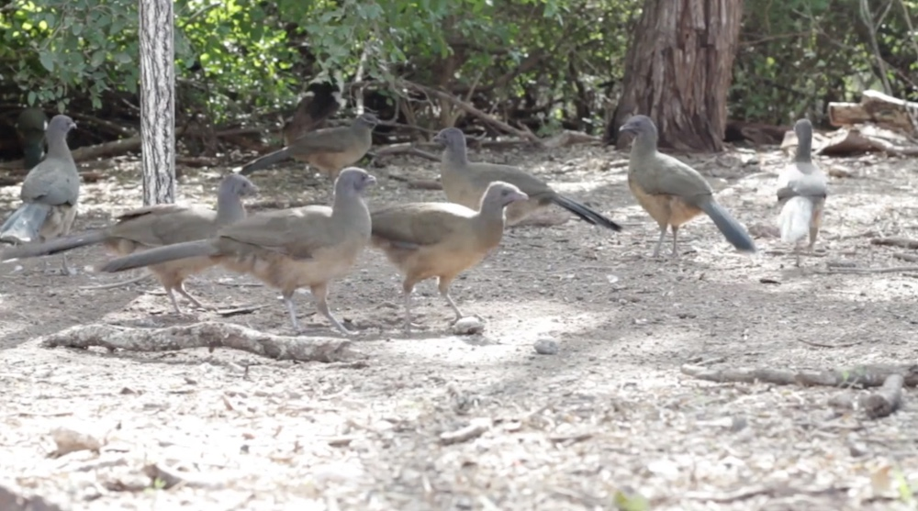

Resolution is 1000x557

## 3.1.1 Result of MSA Optimized version:

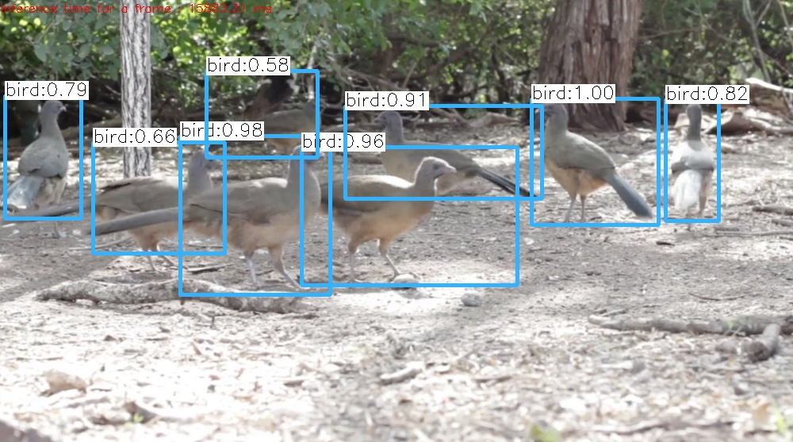

Costs about 15.8 seconds

## 3.1.2 Result of NO-MSA Version:

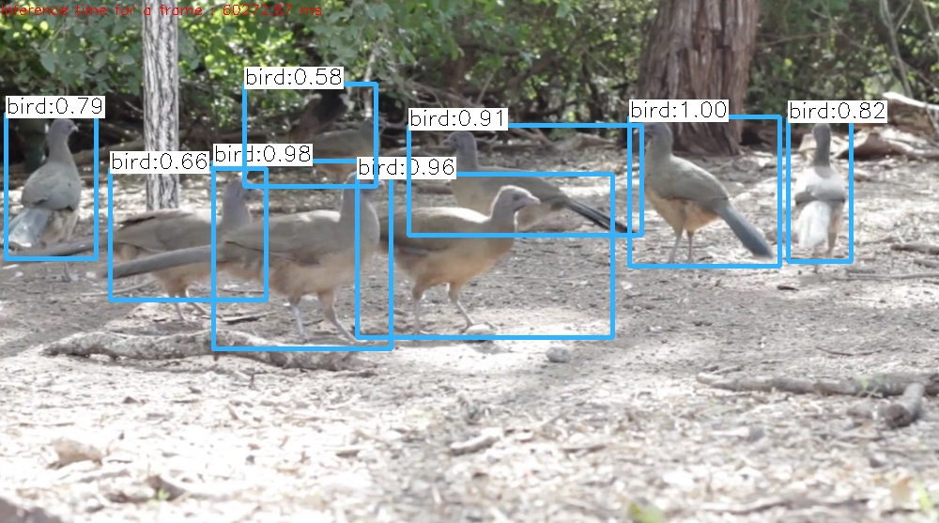

Costs about 60 seconds

## 3.2 Input video



Video info: h264 (High) (avc1 / 0x31637661), yuv420p, 720x400, 889 kb/s, 29.97 fps

## 3.2.1 Result of MSA Optimized version:



Costs about 15.8 seconds per frame

## 3.2.2 Result of NO-MSA Version:



Costs about 60 seconds per frame

# 4, Conclusion

## Obj Detector with picture:

|  |  |  |  |  |
| --- | --- | --- | --- | --- |
|  | **Test-1 (ms)** | **Test-2 (ms)** | **Test-3 (s)** | **Sum (ms)** |
| **MSA** | 15864.9 | 15863.8 | 15883.3 | 47612 |
| **NO-MSA** | 60272.87 | 60233.23 | 60301.93 | 180808.03 |
| **Time Saved** | 44407.97 | 44369.43 | 44418.63 | 133196.03 |
| **Perf Improvement (%)** | 73.7 | 73.7 | 73.7 | 73.7 |
|  |  |  |  |  |
| **Input:** bird.jpg, resolution of 1000x557 **Result:** The performance is promoted 73.7% on average. **Benchmark:** learnopencv/ObjectDetection-YOLO **Machine:** Elise Board R2.5, NO1710005 **ISA:** MIPS32R5 **Compiler:** GCC-6.3.0 **SW Version:**  4.0.1-rc2, run from tmpfs | | | | |

## Obj Detector with video:

|  |  |  |  |  |
| --- | --- | --- | --- | --- |
| **Frame No.** | **MSA Time (ms)** | **NO MSA Time(ms)** | **Time Saved** | **Perf Improvement (%)** |
| 1 | 15,914.11 | 60,397.41 | 44,483.30 | 73.7 |
| 2 | 15,886.36 | 60,368.00 | 44,481.64 | 73.7 |
| 3 | 15,874.13 | 60,332.54 | 44,458.41 | 73.7 |
| 4 | 15,881.11 | 60,334.63 | 44,453.52 | 73.7 |
| 5 | 15,900.85 | 60,366.48 | 44,465.63 | 73.7 |
| 6 | 15,911.05 | 60,399.69 | 44,488.64 | 73.7 |
| 7 | 15,899.59 | 60,210.36 | 44,310.77 | 73.6 |
| 8 | 15,934.77 | 60,213.78 | 44,279.01 | 73.5 |
| 9 | 15,888.73 | 60,338.27 | 44,449.54 | 73.7 |
| 10 | 15,917.64 | 60,354.44 | 44,436.80 | 73.6 |
| 11 | 15,914.60 | 60,325.05 | 44,410.45 | 73.6 |
| 12 | 15,936.76 | 60,330.87 | 44,394.11 | 73.6 |
| 13 | 15,925.61 | 60,405.15 | 44,479.54 | 73.6 |
| 14 | 15,898.90 | 60,246.78 | 44,347.88 | 73.6 |
| 15 | 15,947.14 | 60,322.10 | 44,374.96 | 73.6 |
| 16 | 15,860.98 | 60,402.65 | 44,541.67 | 73.7 |
| 17 | 15,865.14 | 60,330.95 | 44,465.81 | 73.7 |
| 18 | 15,929.39 | 60,347.39 | 44,418.00 | 73.6 |
| 19 | 15,937.13 | 60,337.55 | 44,400.42 | 73.6 |
| 20 | 15,932.56 | 60,310.04 | 44,377.48 | 73.6 |
| 21 | 15,892.05 | 60,357.89 | 44,465.84 | 73.7 |
| 22 | 15,919.06 | 60,382.43 | 44,463.37 | 73.6 |
| 23 | 15,886.39 | 60,311.94 | 44,425.55 | 73.7 |
| 24 | 15,883.97 | 60,344.38 | 44,460.41 | 73.7 |
| 25 | 15,902.89 | 60,347.05 | 44,444.16 | 73.6 |
| 26 | 15,895.10 | 60,280.88 | 44,385.78 | 73.6 |
| 27 | 15,893.23 | 60,311.75 | 44,418.52 | 73.6 |
| 28 | 15,907.09 | 60,284.75 | 44,377.66 | 73.6 |
| 29 | 15,924.18 | 60,304.35 | 44,380.17 | 73.6 |
| 30 | 15,894.58 | 60,305.50 | 44,410.92 | 73.6 |
| 31 | 15,913.82 | 60,398.30 | 44,484.48 | 73.7 |
| 32 | 15,841.94 | 60,323.78 | 44,481.84 | 73.7 |
| 33 | 15,917.20 | 60,335.24 | 44,418.04 | 73.6 |
| 34 | 15,851.64 | 60,452.61 | 44,600.97 | 73.8 |
| 35 | 15,873.53 | 60,353.63 | 44,480.10 | 73.7 |
| 36 | 15,905.90 | 60,337.49 | 44,431.59 | 73.6 |
| 37 | 15,907.03 | 60,321.40 | 44,414.37 | 73.6 |
| 38 | 15,879.52 | 60,370.50 | 44,490.98 | 73.7 |
| 39 | 15,863.22 | 60,261.25 | 44,398.03 | 73.7 |
| 40 | 15,871.94 | 60,366.27 | 44,494.33 | 73.7 |
| 41 | 15,896.36 | 60,399.58 | 44,503.22 | 73.7 |
| 42 | 15,916.19 | 60,361.35 | 44,445.16 | 73.6 |
| 43 | 15,890.02 | 60,304.44 | 44,414.42 | 73.7 |
| 44 | 15,952.97 | 60,339.90 | 44,386.93 | 73.6 |
| 45 | 15,908.52 | 60,309.24 | 44,400.72 | 73.6 |
| 46 | 15,890.45 | 60,330.30 | 44,439.85 | 73.7 |
| 47 | 15,910.33 | 60,328.57 | 44,418.24 | 73.6 |
| 48 | 15,889.55 | 60,378.83 | 44,489.28 | 73.7 |
| 49 | 15,920.49 | 60,341.81 | 44,421.32 | 73.6 |
| 50 | 15,893.55 | 60,319.89 | 44,426.34 | 73.7 |
| 51 | 15,894.22 | 60,320.27 | 44,426.05 | 73.7 |
| 52 | 15,876.36 | 60,351.58 | 44,475.22 | 73.7 |
| 53 | 15,845.93 | 60,357.37 | 44,511.44 | 73.7 |
| 54 | 15,872.02 | 60,332.27 | 44,460.25 | 73.7 |
| 55 | 15,872.41 | 60,299.89 | 44,427.48 | 73.7 |
| 56 | 15,865.13 | 60,266.97 | 44,401.84 | 73.7 |
| 57 | 15,940.48 | 60,475.26 | 44,534.78 | 73.6 |
| 58 | 15,938.10 | 60,340.01 | 44,401.91 | 73.6 |
| 59 | 15,915.12 | 60,345.16 | 44,430.04 | 73.6 |
| 60 | 15,887.51 | 60,292.87 | 44,405.36 | 73.6 |
| 61 | 15,859.44 | 60,289.57 | 44,430.13 | 73.7 |
| 62 | 15,879.01 | 60,339.48 | 44,460.47 | 73.7 |
| 63 | 15,911.58 | 60,315.59 | 44,404.01 | 73.6 |
| 64 | 15,879.75 | 60,321.55 | 44,441.80 | 73.7 |
| 65 | 15,904.54 | 60,321.24 | 44,416.70 | 73.6 |
| 66 | 15,883.54 | 60,331.67 | 44,448.13 | 73.7 |
| 67 | 15,908.23 | 60,328.18 | 44,419.95 | 73.6 |
| 68 | 15,934.34 | 60,268.98 | 44,334.64 | 73.6 |
| 69 | 15,888.30 | 60,348.78 | 44,460.48 | 73.7 |
| 70 | 15,919.67 | 60,295.44 | 44,375.77 | 73.6 |
| 71 | 15,857.61 | 60,320.69 | 44,463.08 | 73.7 |
| 72 | 15,898.56 | 60,366.74 | 44,468.18 | 73.7 |
| 73 | 15,903.01 | 60,385.49 | 44,482.48 | 73.7 |
| 74 | 15,877.70 | 60,347.28 | 44,469.58 | 73.7 |
| 75 | 15,879.50 | 60,312.92 | 44,433.42 | 73.7 |
| 76 | 15,869.96 | 60,333.66 | 44,463.70 | 73.7 |
| 77 | 15,907.79 | 60,303.40 | 44,395.61 | 73.6 |
| 78 | 15,894.32 | 60,355.35 | 44,461.03 | 73.7 |
| 79 | 15,926.93 | 60,335.99 | 44,409.06 | 73.6 |
| 80 | 15,859.46 | 60,304.97 | 44,445.51 | 73.7 |
| 81 | 15,881.29 | 60,367.33 | 44,486.04 | 73.7 |
| 82 | 15,898.99 | 60,355.93 | 44,456.94 | 73.7 |
| 83 | 15,859.49 | 60,386.04 | 44,526.55 | 73.7 |
| 84 | 15,962.19 | 60,264.87 | 44,302.68 | 73.5 |
| 85 | 15,888.61 | 60,283.11 | 44,394.50 | 73.6 |
| 86 | 15,897.30 | 60,297.79 | 44,400.49 | 73.6 |
| 87 | 15,875.71 | 60,409.76 | 44,534.05 | 73.7 |
| 88 | 15,899.52 | 60,277.93 | 44,378.41 | 73.6 |
| 89 | 15,896.84 | 60,332.95 | 44,436.11 | 73.7 |
| 90 | 15,916.07 | 60,299.40 | 44,383.33 | 73.6 |
| 91 | 15,892.58 | 60,289.37 | 44,396.79 | 73.6 |
| 92 | 15,914.64 | 60,242.18 | 44,327.54 | 73.6 |
| 93 | 15,902.42 | 60,323.16 | 44,420.74 | 73.6 |
| 94 | 15,900.99 | 60,379.18 | 44,478.19 | 73.7 |
| 95 | 15,895.26 | 60,365.11 | 44,469.85 | 73.7 |
| 96 | 15,851.13 | 60,308.16 | 44,457.03 | 73.7 |
| 97 | 15,899.82 | 60,377.89 | 44,478.07 | 73.7 |
| 98 | 15,883.04 | 60,305.02 | 44,421.98 | 73.7 |
| 99 | 15,893.28 | 60,299.04 | 44,405.76 | 73.6 |
| 100 | 15,928.82 | 60,306.86 | 44,378.04 | 73.6 |
| 101 | 15,861.46 | 60,328.09 | 44,466.63 | 73.7 |
| 102 | 15,925.73 | 60,339.93 | 44,414.20 | 73.6 |
| 103 | 15,902.75 | 60,323.29 | 44,420.54 | 73.6 |
| 104 | 15,906.96 | 60,345.13 | 44,438.17 | 73.6 |
| 105 | 15,946.59 | 60,314.70 | 44,368.11 | 73.6 |
| 106 | 15,894.14 | 60,363.30 | 44,469.16 | 73.7 |
| 107 | 15,921.61 | 60,365.12 | 44,443.51 | 73.6 |
| 108 | 15,900.20 | 60,350.79 | 44,450.59 | 73.7 |
| 109 | 15,889.95 | 60,289.98 | 44,400.03 | 73.6 |
| 110 | 15,888.31 | 60,313.47 | 44,425.16 | 73.7 |
| 111 | 15,898.67 | 60,365.20 | 44,466.53 | 73.7 |
| 112 | 15,913.33 | 60,369.85 | 44,456.52 | 73.6 |
| 113 | 15,871.24 | 60,336.96 | 44,465.72 | 73.7 |
| 114 | 15,922.62 | 60,338.94 | 44,416.32 | 73.6 |
| 115 | 15,894.24 | 60,381.74 | 44,487.50 | 73.7 |
| 116 | 15,927.57 | 60,387.72 | 44,460.15 | 73.6 |
| 117 | 15,876.40 | 60,319.24 | 44,442.84 | 73.7 |
| 118 | 15,911.20 | 60,341.34 | 44,430.14 | 73.6 |
| 119 | 15,871.78 | 60,358.83 | 44,487.05 | 73.7 |
| 120 | 15,859.62 | 60,303.95 | 44,444.33 | 73.7 |
| 121 | 15,875.40 | 60,309.64 | 44,434.24 | 73.7 |
| 122 | 15,910.47 | 60,353.95 | 44,443.48 | 73.6 |
| 123 | 15,901.13 | 60,351.00 | 44,449.87 | 73.7 |
| 124 | 15,879.79 | 60,346.54 | 44,466.75 | 73.7 |
| 125 | 15,917.87 | 60,342.32 | 44,424.45 | 73.6 |
| 126 | 15,887.86 | 60,320.07 | 44,432.21 | 73.7 |
| 127 | 15,900.03 | 60,377.46 | 44,477.43 | 73.7 |
| 128 | 15,939.37 | 60,402.84 | 44,463.47 | 73.6 |
| 129 | 15,900.80 | 60,369.33 | 44,468.53 | 73.7 |
| 130 | 15,914.95 | 60,331.95 | 44,417.00 | 73.6 |
| 131 | 15,913.33 | 60,376.39 | 44,463.06 | 73.6 |
| 132 | 15,933.63 | 60,270.82 | 44,337.19 | 73.6 |
| 133 | 15,914.06 | 60,355.94 | 44,441.88 | 73.6 |
| 134 | 15,918.20 | 60,320.78 | 44,402.58 | 73.6 |
| 135 | 15,913.56 | 60,310.06 | 44,396.50 | 73.6 |
| 136 | 15,870.08 | 60,309.25 | 44,439.17 | 73.7 |
| 137 | 15,859.67 | 60,290.12 | 44,430.45 | 73.7 |
| 138 | 15,841.19 | 60,331.85 | 44,490.66 | 73.7 |
| 139 | 15,911.79 | 60,294.64 | 44,382.85 | 73.6 |
| 140 | 15,844.91 | 60,241.76 | 44,396.85 | 73.7 |
| 141 | 15,935.84 | 60,416.96 | 44,481.12 | 73.6 |
| 142 | 15,908.27 | 60,302.18 | 44,393.91 | 73.6 |
| 143 | 15,911.05 | 60,322.49 | 44,411.44 | 73.6 |
| 144 | 15,906.50 | 60,293.85 | 44,387.35 | 73.6 |
| 145 | 15,957.30 | 60,244.67 | 44,287.37 | 73.5 |
| 146 | 15,892.53 | 60,348.46 | 44,455.93 | 73.7 |
| 147 | 15,931.44 | 60,248.10 | 44,316.66 | 73.6 |
| 148 | 15,909.02 | 60,387.34 | 44,478.32 | 73.7 |
| 149 | 15,876.83 | 60,227.64 | 44,350.81 | 73.6 |
| 150 | 15,937.77 | 60,301.46 | 44,363.69 | 73.6 |
| **Total** | **2,384,836.78** | **9,049,756.56** | **6,664,919.78** | 73.6 |
|  |  |  |  |  |
| **Input:** run.mp4, 720x400, 29.97 fps **Result:** The performance is promoted 73.6% on average. **Benchmark:** learnopencv/ObjectDetection-YOLO **Machine:** Elise Board R2.5, NO1710005 **ISA:** MIPS32R5 **Compiler:** GCC-6.3.0 **SW Version:**  4.0.1-rc2, run from tmpfs | | | | |